**ENG2DI**

**News Report Writing:** What Makes a Good News Report

1. **A catchy Headline and sometimes a Sub-Headline: reflects the focus of the article; usually touches on at least one of the 5 Ws**
2. **Byline and Place Line: identifies the individual— journalist —who wrote the article and where the events occurred**
3. **Lead—**first paragraph(s): in your first one or two sentences tell **who, what, when, where**. Give the specific details; capture reader interest and list the pertinent information related to the article’s headline.
   1. Hook the reader by beginning with an effectively clever statement that provides details related to the news article
4. **Body Paragraphs: second, third, fourth, etc … paragraphs**Gives readers the details: the facts. **Include QUOTATIONS from eye-WITNESSES, Important individuals, etc …**!
   1. Discuss details related to the 5 Ws; answering the **Why & How**
   2. Write in the third person: he, she, they, the individuals, the people, etc …
   3. Be objective—**do not state your personal opinions**: only provide facts
   4. Use quotations to express and convey the eyewitness’s comments/ideas
   5. Opinions should only be expressed through quotations
5. **Last paragraph:**
   1. Wrap it up somehow: don't leave the reader hanging
   2. Don't say...."In conclusion" or "To finish..."
   3. Try ending with a quotation or with a catchy phrase, obviously strongly related to the article’s content; leave reader with follow up details: possible next steps; no opinions

**The INVERTED PYRAMID:**

* 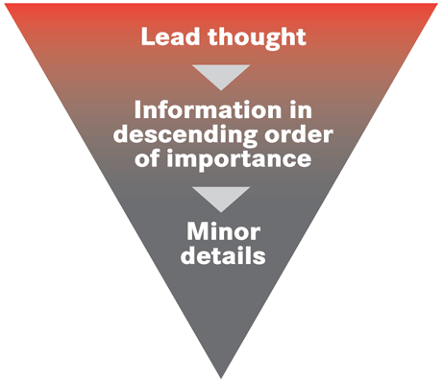Provide the most relevant and related information first: info related **specifically to the headline and sub-headline**; 5Ws
* Use the top down approach— **Inverted Pyramid** —most important to least important information
* Use active words: verbs that show what really happened
* Write newspaper articles in the immediate past tense: obviously, the events occur in the past! **Write as if the events occurred yesterday**
* Write down specific words from the eyewitness; important people: use quotations
* Give the really interesting and eye-catching information first
* ***Small paragraphs: 2 or 3 sentences per paragraph***